Project Development Phase
Model Performance Test

Date | 28 September 2026
Team ID | 6ab2210011b716a3e52c62c6
Project Name | Streamlining IT Procurement: Automating Standard Laptop Orders with Flow Designer
Maximum Marks | 10 Marks

Model Performance Testing:
Project team shall fill the following information in model performance testing template.
S.No. | Parameter | Values | Screenshot
1. | Metrics | Regression Model: Not applicable  Classification Model: Not applicable  This project is a rule-based ServiceNow Flow Designer automation, not an ML model. Performance is measured by result: after approval, a Catalog Task was created automatically with short description "Laptop needs to Configured" and assigned to the Hardware group. | 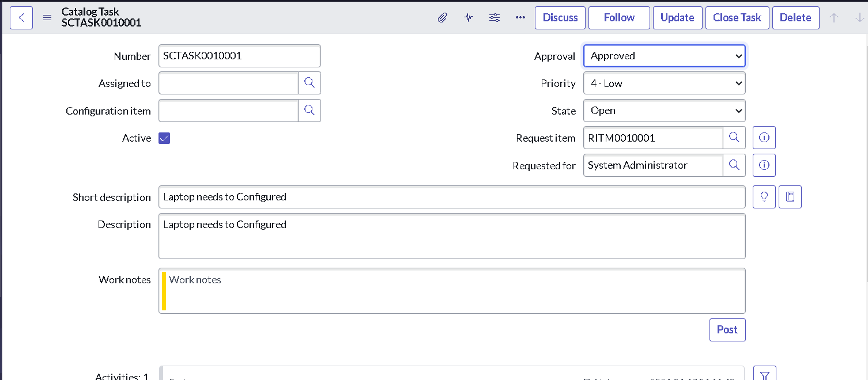  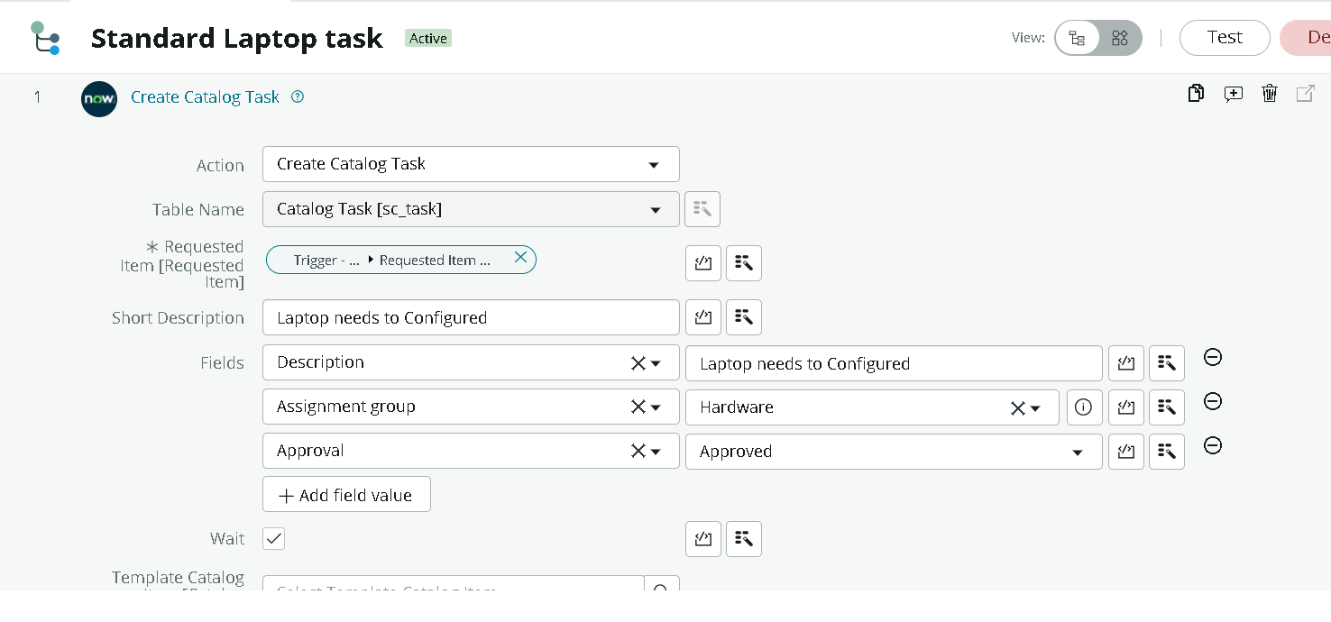
2. | Tune the Model | Hyperparameter Tuning - Not applicable  Validation Method - Manual testing: placed a Standard Laptop order from Service Catalog, approved it, and verified the Catalog Task. | 